**R- Computer - Lab #2**

**Student:** Erna Guðrún Björnsdóttir

**Partner :** Guðrún Alma Einarsdóttir

1. ***A)*** Item number 5 was the easiest, -1.626 and item number 10 was the hardest 0.539.

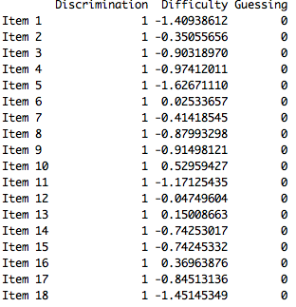

***B)*** Spot where the probability of correctly answering the question 5 is between -1,88 and -1,37 with 95% confident.

***-1,63 - 1.96 x 0,13 = -1,88***

***-1,63 + 1.96 x 0,13 = -1,37***

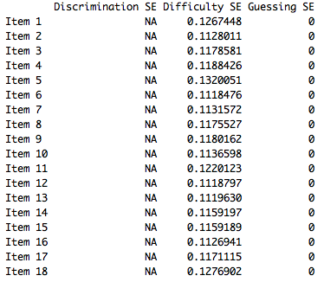

***C)*** Item 5 - Easiest Item 10 - Hardest

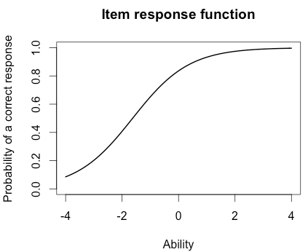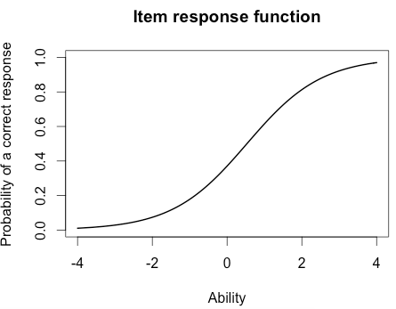

Item 5 is the black line and item 10 is the red line.

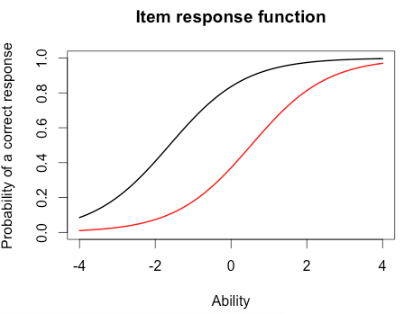

***D)*** For the easiest item it would be around 0.8 and for the hardest item about 0.3.

***E)*** **For the person who did best on the test his score was 3.99**

> which.max(est_abl$est) # Prints out the person with the maximum score

[1] 49

est sem n

49. 3.999921 2.204373 18

**For the person who did worst on the test his score was -3.99**

> which.min(est_abl$est) # Prints out the person minimum score

[1] 393

est sem n

393. -3.999947 1.225286 18

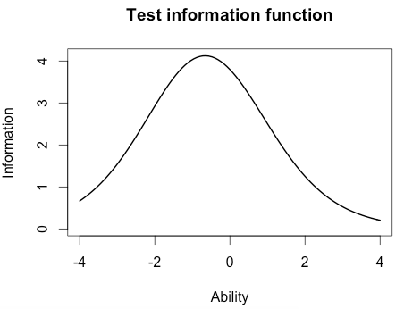

***F)*** The person that did best on the test, his ability estimate was between 0,322 and 8,30 with 95% confidence.

***3.99 - 1.96 x 2,2 = -0,322***

***3.99 + 1.96 x 2,2 = 8,30***

1. ***A)*** I chose item number 1, 7 and 17.

***B)*** Plot for item 1= black, 7 = red and 17 = green.

> plot(iif(est_params[c(1,7,17),]), co = NA)

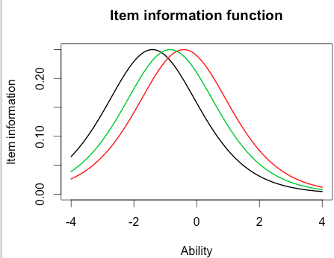

***C)*** **Same =** Most information about these items are located at -2 and 0.

**Different =** All the items have different ability estimate.

***D)*** plot(tif(est_params))

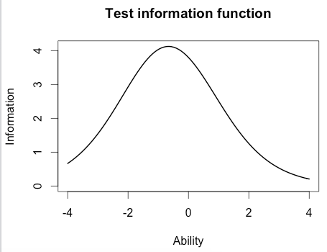

***E)*** The majority of the information is located between -2 and 1

1. ***A)*** Item 8 has the highest discrimination 2.288 and item 12 has the lowest discrimination 0.332.

***B)*** No not quite, item 10 is still the hardest but item 1 is now the easiest.

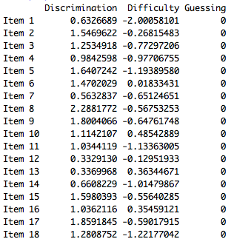

***C)*** The correlation between the ability estimates on the Rasch model and 2-PL is 0.97. If you are high in ability on the Rasch model you will also be high in ability on the 2-PL model because the correlation between the two models is very high.

> # Correlation between the ability estimates

> cor(twopl_abl$est,est_abl$est)

[1] 0.9709497

***D)*** > plot(iif(twopl_params[c(1,7,17),]), co = NA)

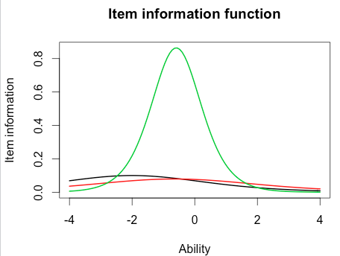

E) The items do not have the same discrimination and difficulty.

In the 2-PL model we have the discrimination factor that helps us discriminate more easily between items information and ability estimate, but the Rasch model only tells us about item location/difficulty.